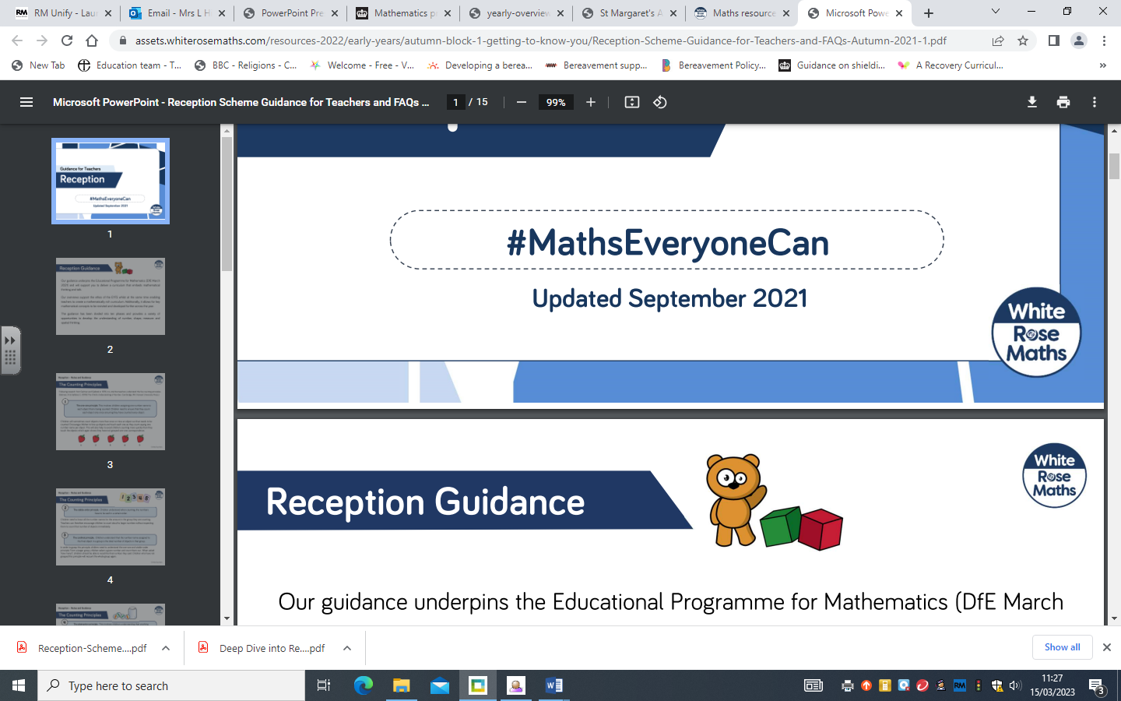

**Whole school Curriculum**

**Maths Overview**

|  |  |  |  |  |  |  |  |
| --- | --- | --- | --- | --- | --- | --- | --- |
| **Term** | **Reception** | **Year 1** | **Year 2** | **Year 3** | **Year 4** | **Year 5** | **Year 6** |
| **Autumn** | Match and sort  Compare amounts  Compare size, mass and capacity  Exploring pattern  Representing 1,2 and 3  Comparing 1, 2 and 3  Composition of 1, 2 and 3  Circles and triangles  Positional language represent numbers to 6  One more or less  Shapes with 4 sides  Time | Place value (within 10)  Addition and subtraction (within 10)  Geometry - shape | Place value  Addition and subtraction  Geometry - shape | Place value  Addition and subtraction  Multiplication and division | Place value  Addition and subtraction  Multiplication and division | Place value  Addition and subtraction  Multiplication and division  Fractions | Place value  Addition and subtraction  Multiplication and division  Fractions |
| **Spring** | Introducing zero  Comparing numbers to 5  Composition of 4 and 5  Compare mass  Compare capacity  6, 7 and 8  Combining two amounts  Making pairs  Length and height  Time  Counting to 9 and 10  Comparing numbers to 10  Bonds to 10  3D shapes | Place value (within 20)  Addition and subtraction (within 20)  Place value (within 50)  Length and height  Mass and volume | Money  Multiplication and division  Length and height  Mass, capacity and temperature | Multiplication and division  Length and perimeter  Fractions  Mass and capacity | Multiplication and division  Length and perimeter  Fractions  Decimals | Multiplication and division  Fractions  Decimals and percentages  Perimeter and area  Statistics | Ratio  Algebra  Decimals  Fractions, decimals and percentages  Area, perimeter and volume  Statistics |
| **Summer** | Build numbers to 20 and beyond  Spatial reasoning  Match, rotate, manipulate  Adding more  Taking away  Spatial reasoning  Compose and decompose  Doubling  Sharing and grouping  Even and odd  Visualise, build and map | Multiplication and division  Fractions  Geometry – position and direction  Place value (within 100)  Measurement – money and time | Fractions  Time  Statistics  Position and direction | Fractions  Money  Time  Shape  Statistics | Decimals  Money  Time  Shape  Statistics  Position and Direction | Shape  Position and direction  Decimals  Number – negative numbers  Converting units  Measurement - Volume | Shape  Geometry – position and direction  Problem solving/consolidation |